Machine Learning Overview

“Field of study that gives computers the ability to learn without being explicitly programmed.”

* Arthur Samuel (1959)

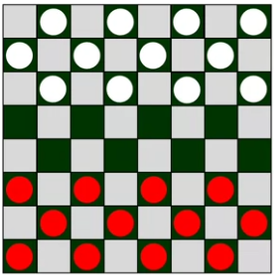

* If Arthur Samuel's checkers-playing program had been allowed to play only 10 games (instead of tens of thousands games) against itself, how would this have affected its performance?
  + Would have made it worse

Machine learning algorithms

* Supervised learning
  + Used most in real-world applications
  + Rapid advancements
  + Course 1,2
* Unsupervised learning
  + Course 3
* Recommender systems
* Reinforcement

Supervised Learning

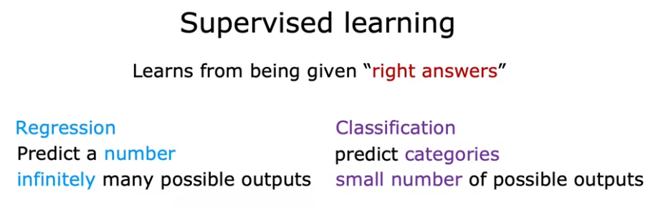

Input to output label

The learning algorithm learns from being given right answers, the correct label y for a given input x, and by seeing correct pairs of input x and desired output label y, the machine can eventually evaluate correct output by given only the input.

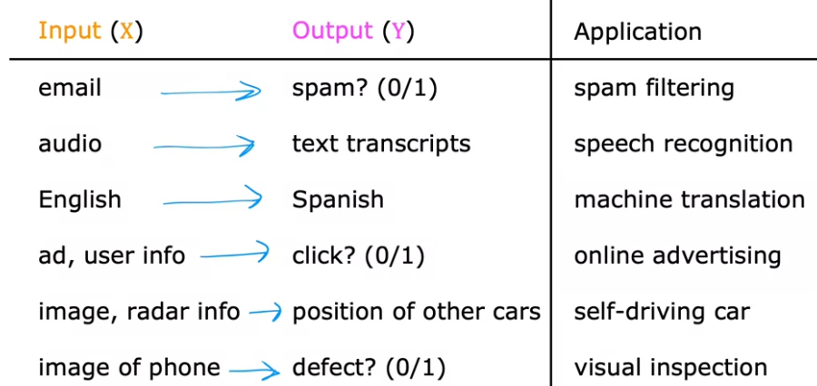

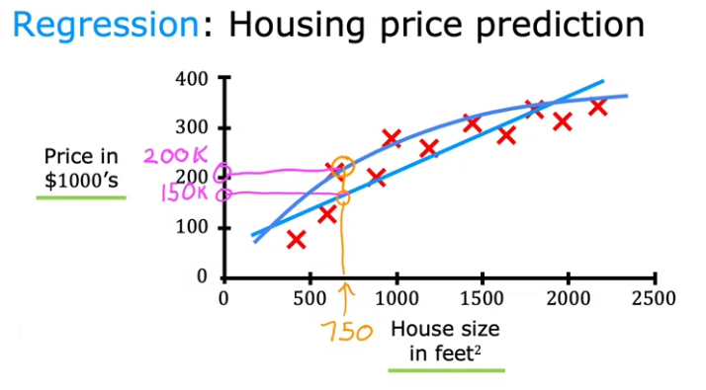

* Right answer here: the house prize
* Regression:
  + Predict a number from infinitely many possible outputs.

Classification Algorithm

Classification: Breast cancer detection

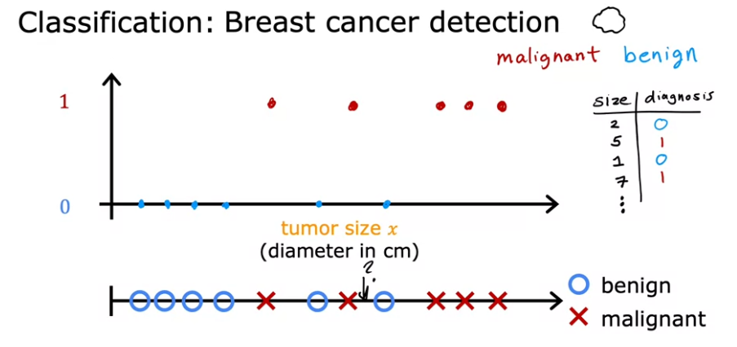

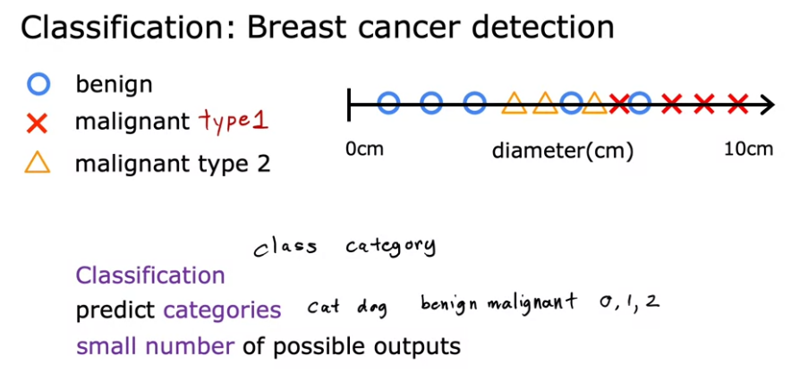

Two or more inputs:

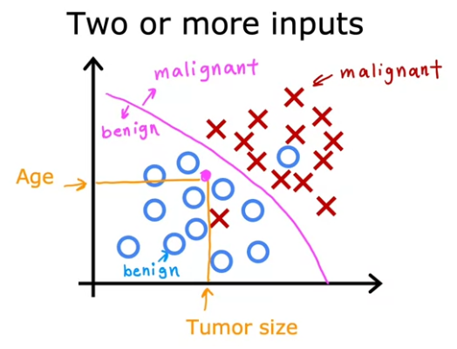

* There can be many more inputs

Unsupervised learning - clustering

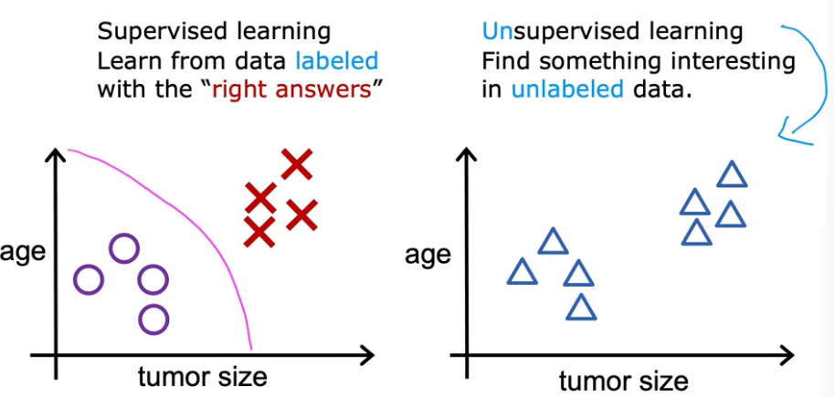

* Given data that isn’t associated with any output label

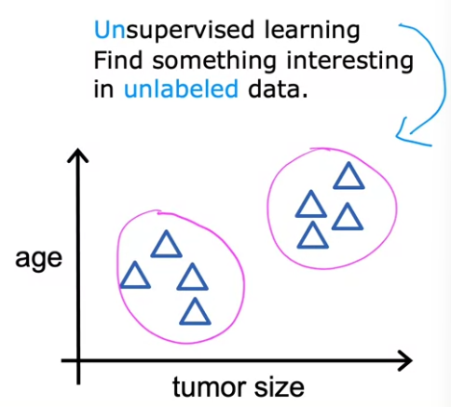

* To find something interesting in unlabeled data (e.g. pattern/structure)
* An unsupervised learning algorithm, might decide that the data can be assigned to two different groups or two different clusters (clustering algorithm)
* Example:

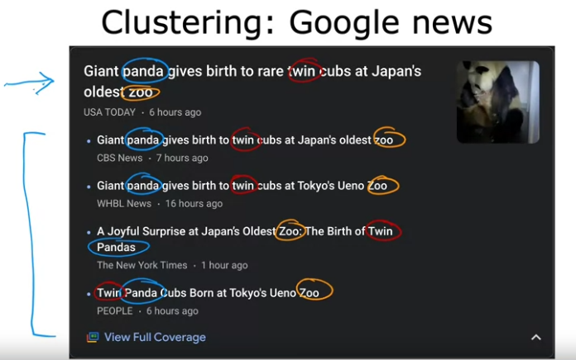

* Group related stories together
* 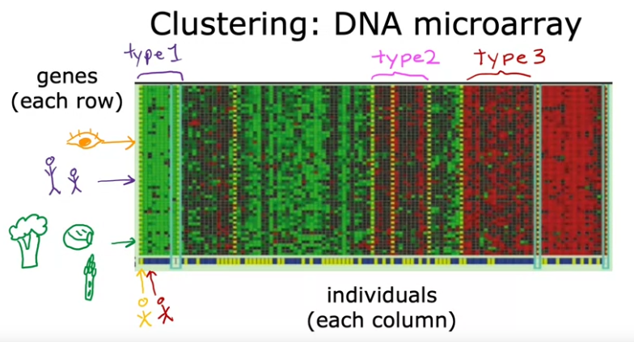

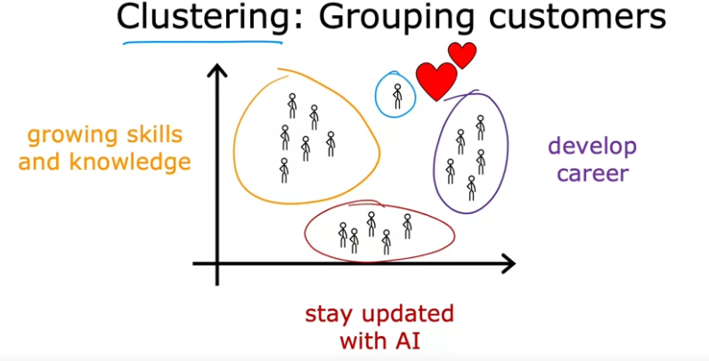

Unsupervised learning

Clustering:

* Group similar data points together

Anomaly detection

* Find unusual data points

Dimensionality reduction

* Compress data using fewer numbers.
* While losing as little information as possible

Jupter Notebook

Linear Regression with one variable

* Fitting a straight line to your data

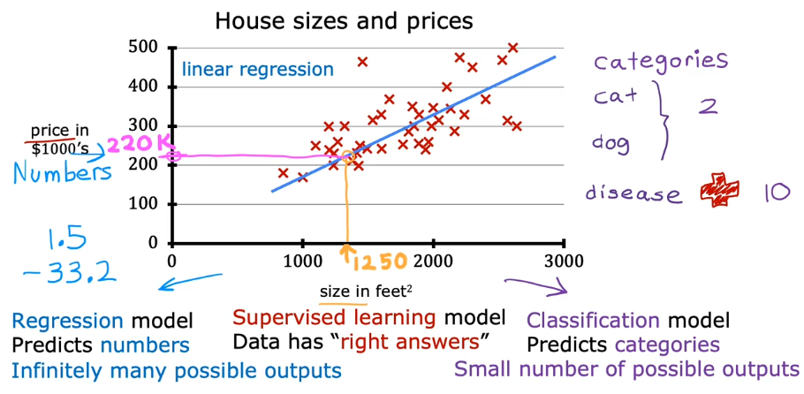

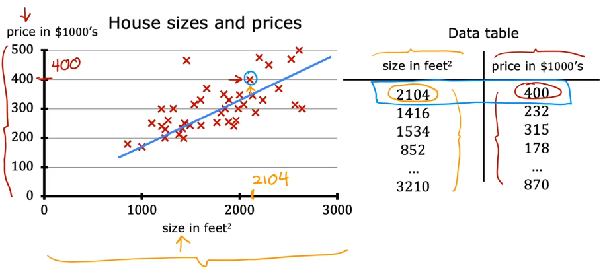

Terminology

* Training model train from a training set

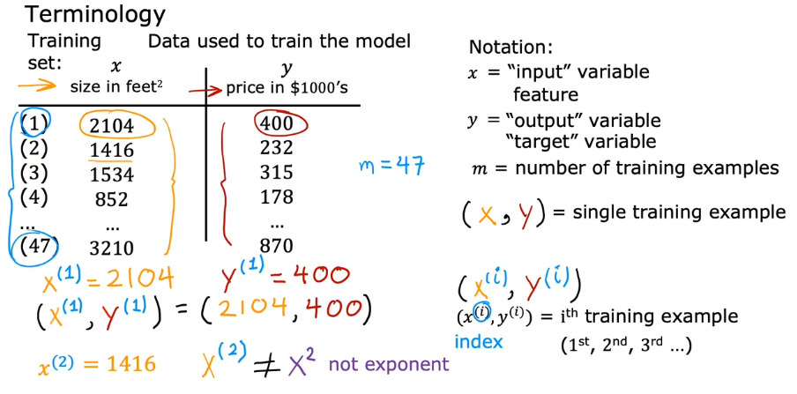

* 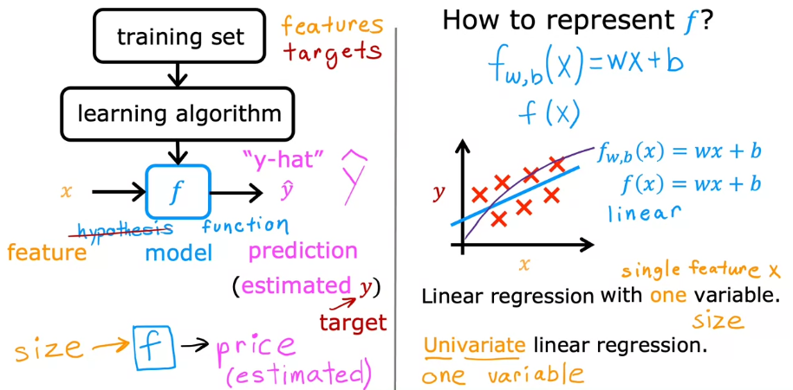

Cost Function

* 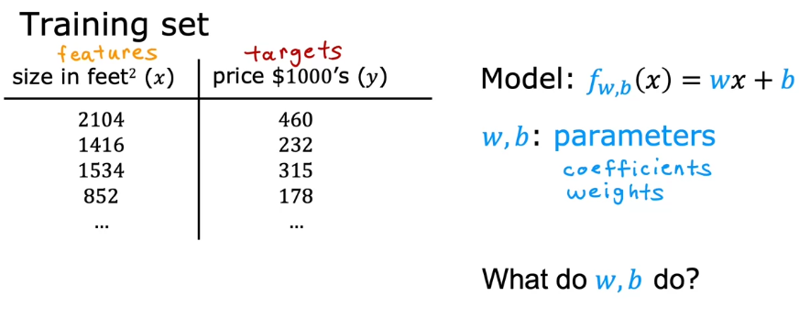
* 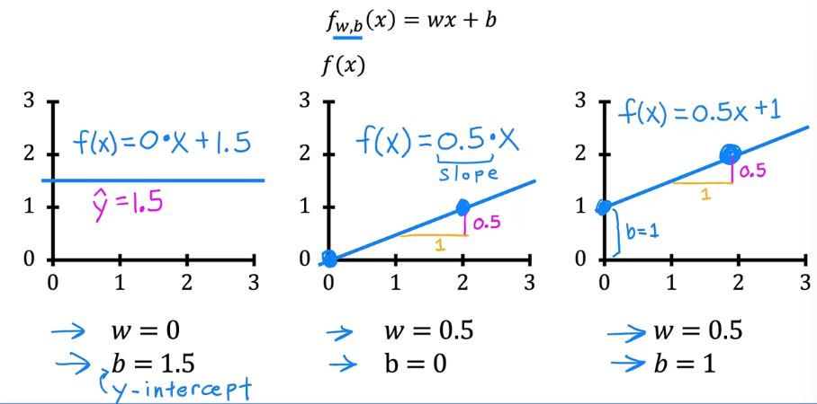

Cost Function

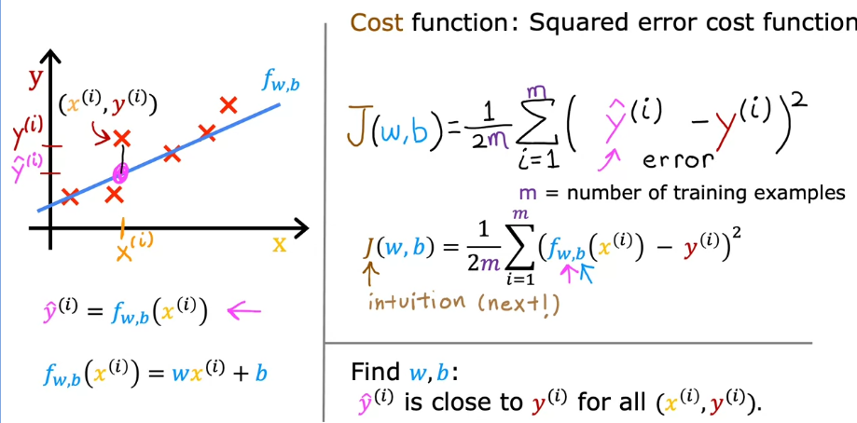

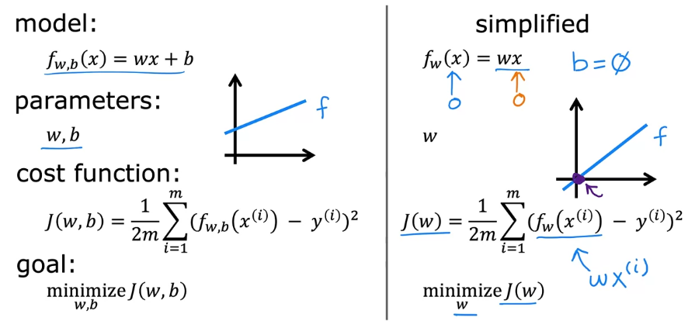

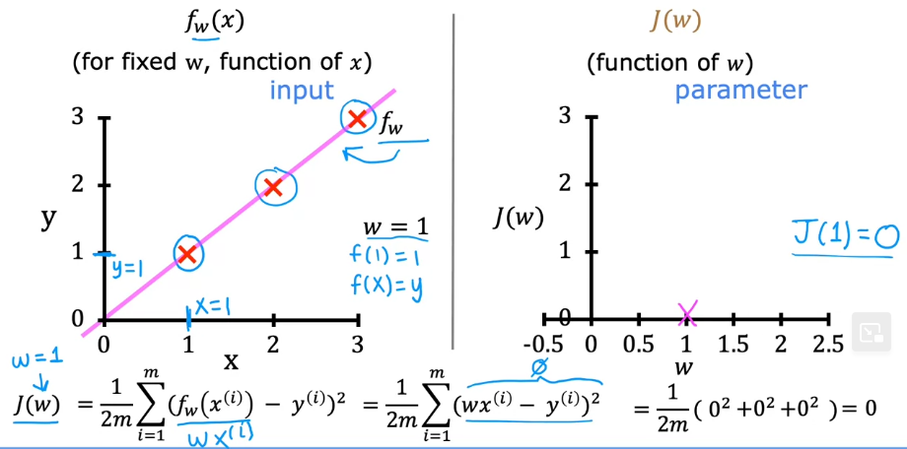

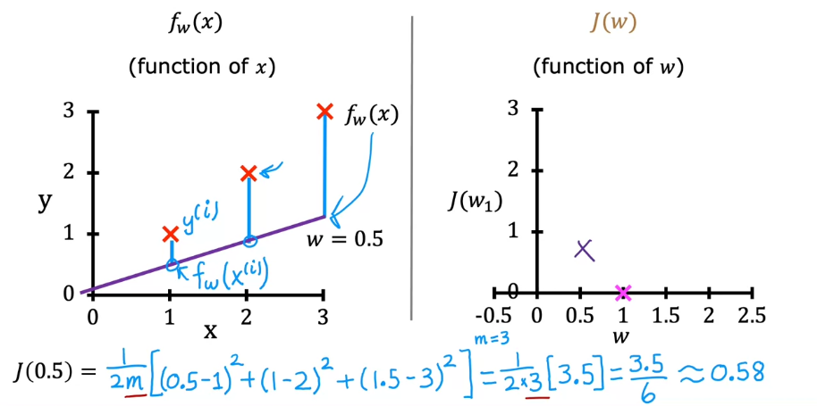

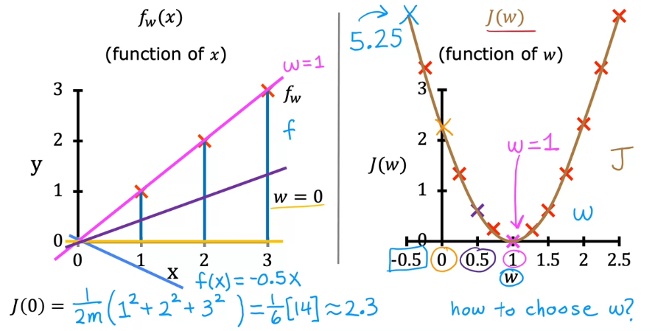

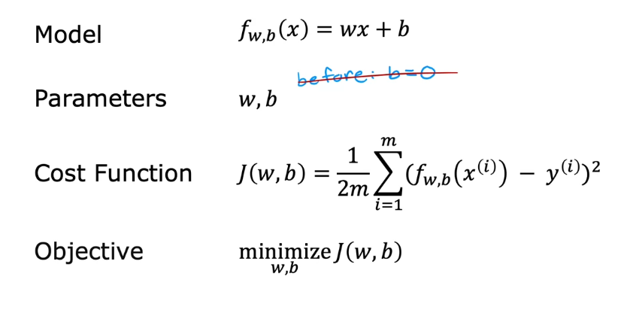

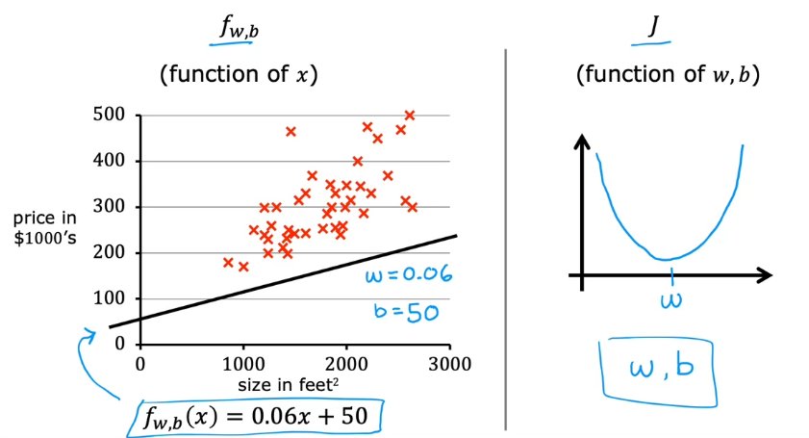

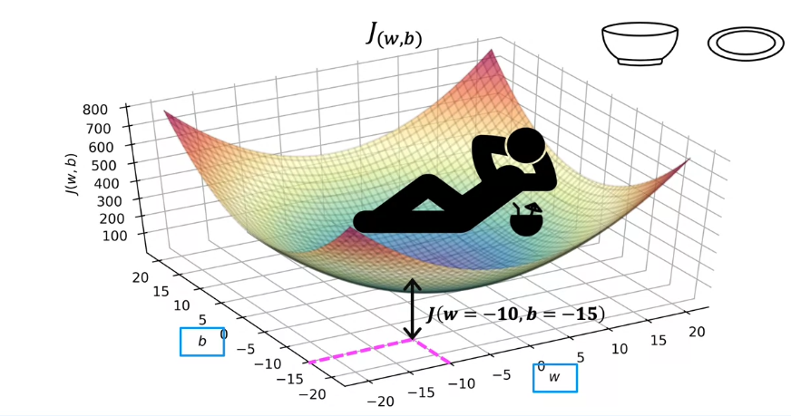

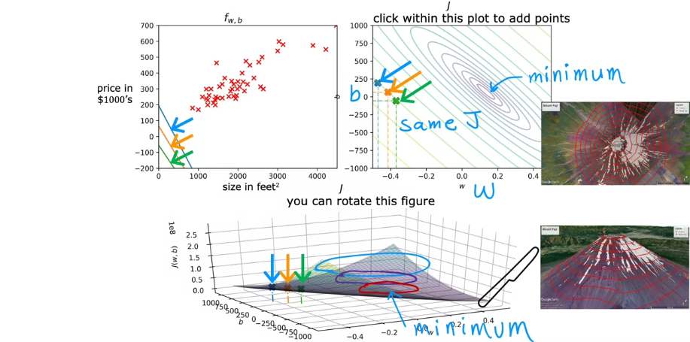

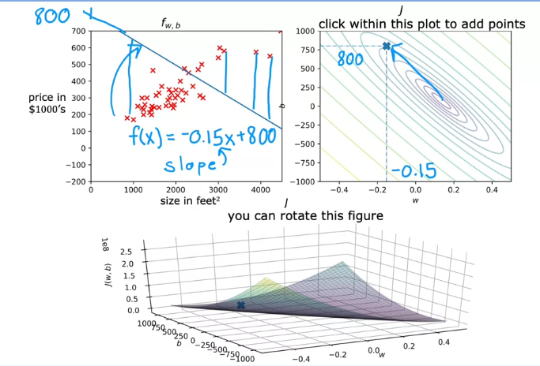

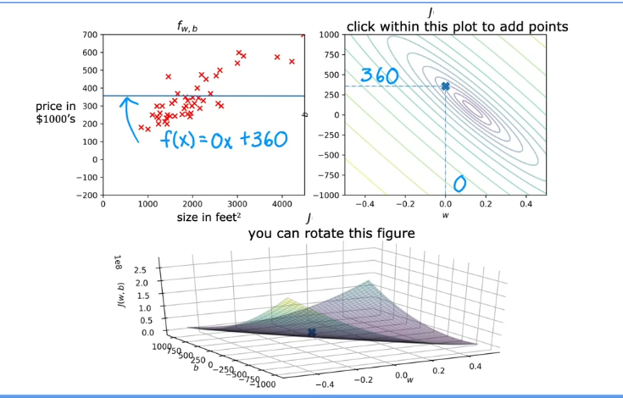

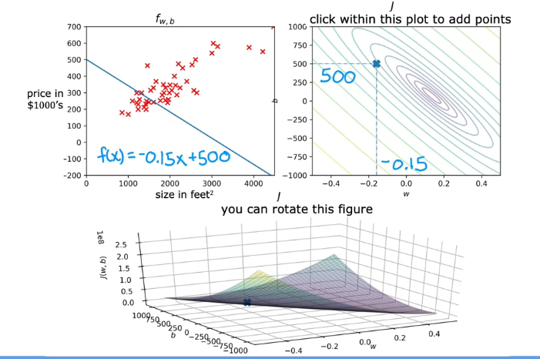

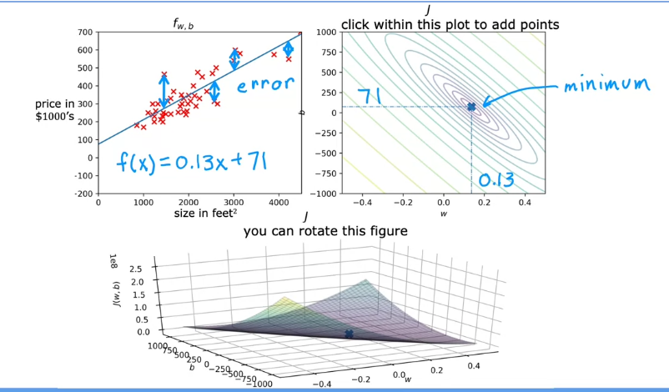

Gradient Descent

* Used to minimize any functions

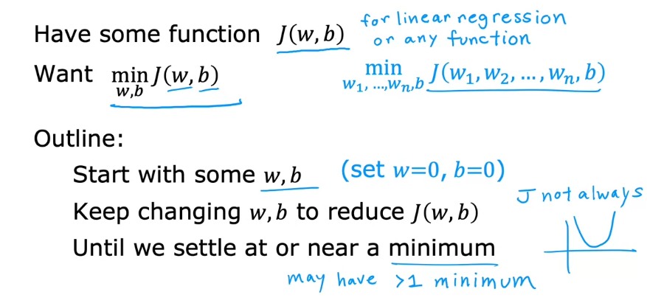

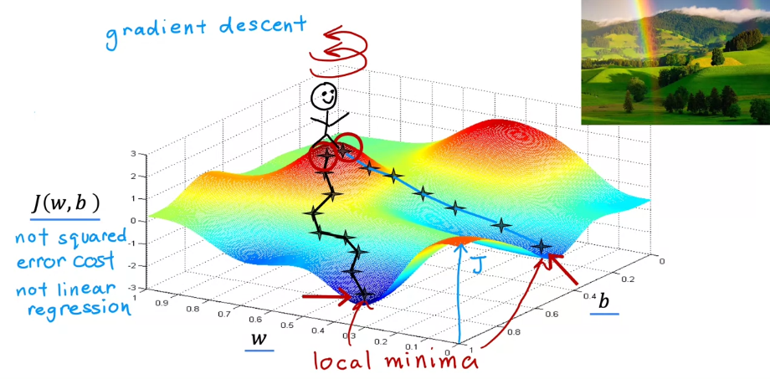

Gradient Descent Algorithm

Alpha: learning rate: how big is your step downhill

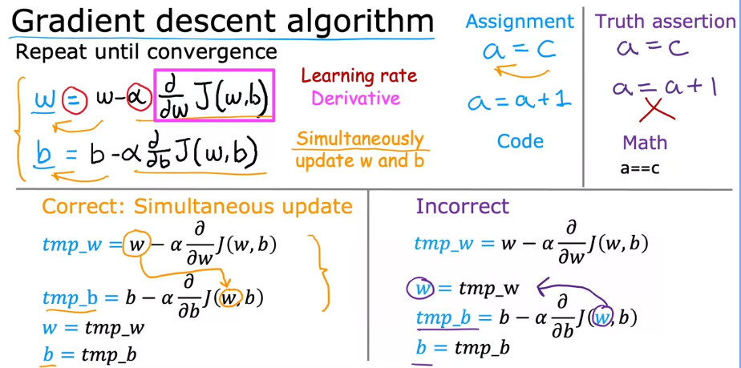

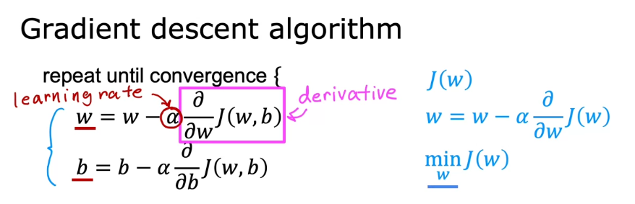

* Actually partial derivative

Learning rate

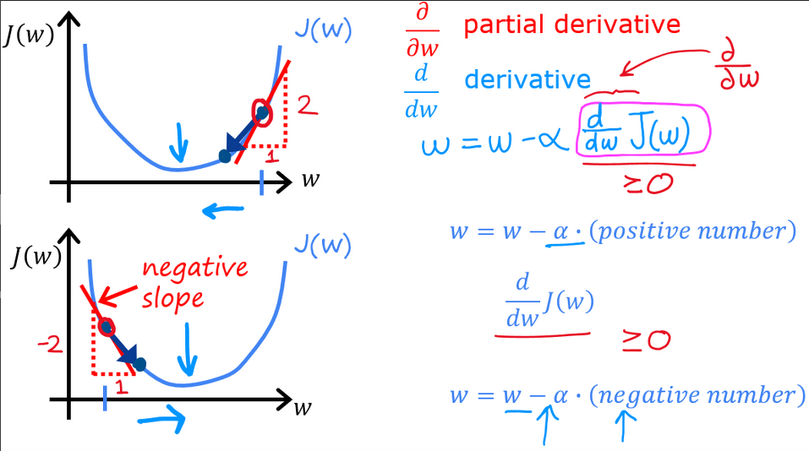

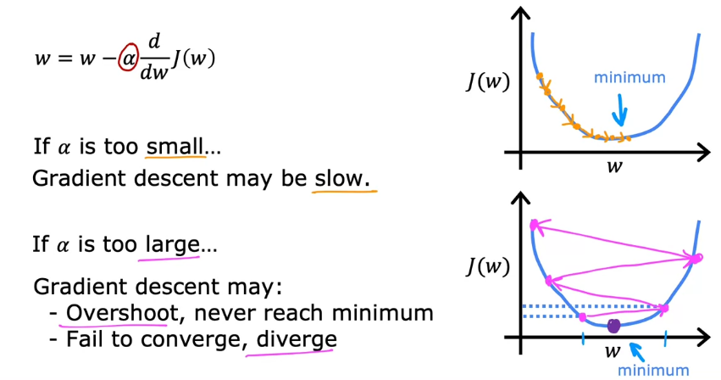

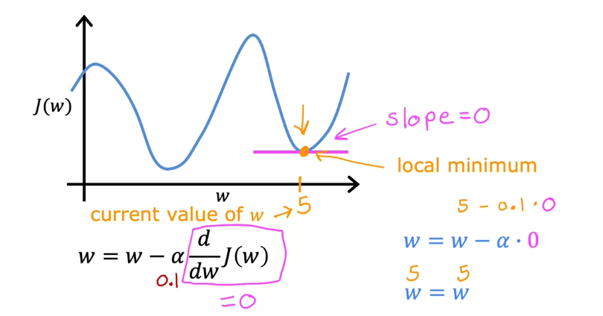

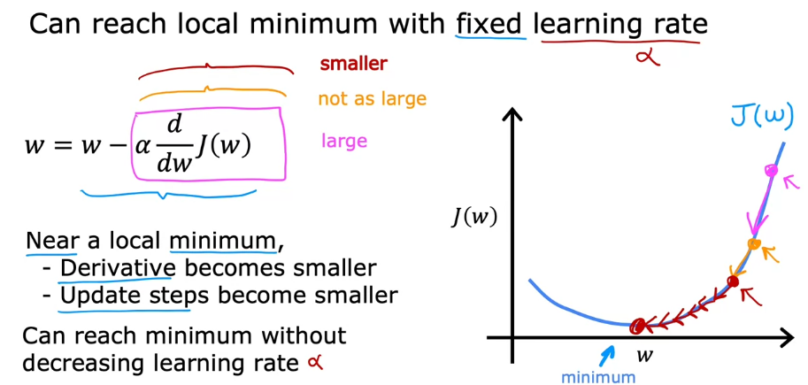

Gradient descent for linear regression

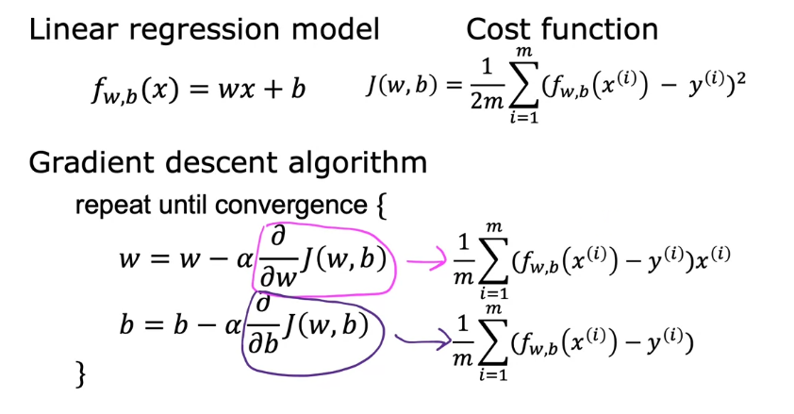

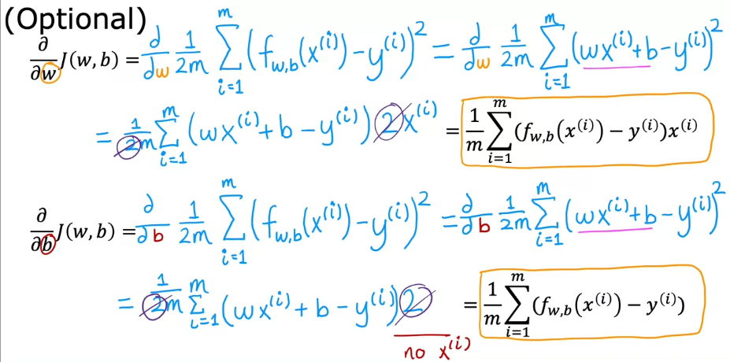

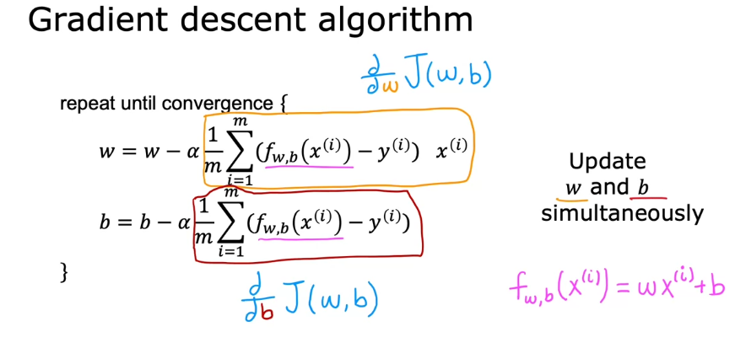

It leads to a local minimum

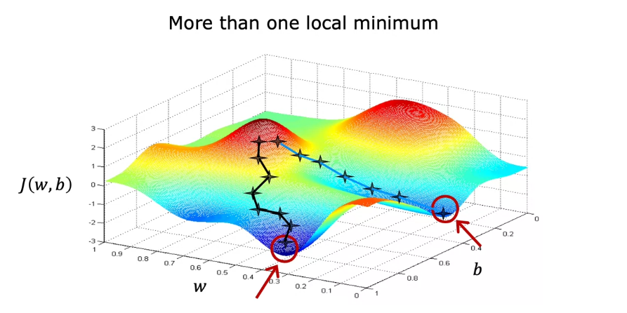

Square error cost function has only a single global minimum

